After started P1 WITH A PLUGGED-IN USB-Mouse and closed PFAFF-Panel-Software
(cross right above), there is this screen. Now click the network symbol (green arrow):
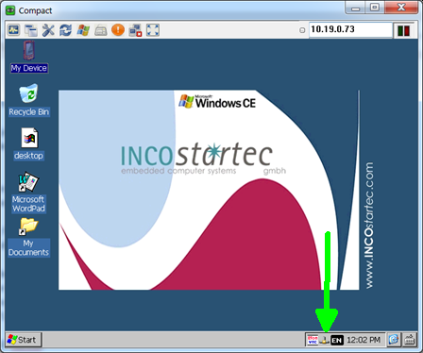
then click details:
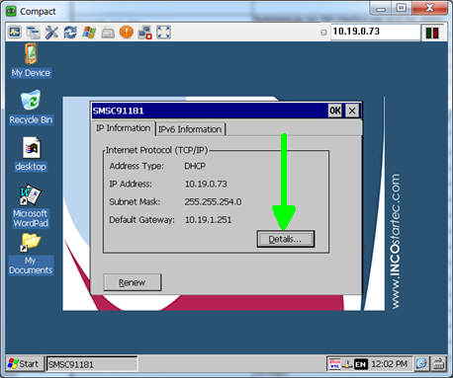

After that you can read the physical address of the P1 panel: (MAC-adress)
